What’s your value proposition?

In my experience auditing dozens of websites I’ve found that very few have a clear value proposition identified for prospective customers. Most of the time I have to weed through lists of product features to find anything that even remotely feels like value. So, I’ll attempt to help you quickly identify your value proposition here and even provide you with a free value proposition generator, read on...

What is a value proposition?
A value proposition is simply a description of the value your company promises to deliver.

So, how do you define value?

- This value needs to be important from the customer’s perspective, not from your view. For example, my business may offer 24-hour customer support, which I see as delivering great value, but if the client never needs to call after 5 pm then there is no benefit from their perspective.

- The value needs to be relevant, significant, and critical to the prospect. It needs to promise something that is desirable enough for them to invest money in to obtain. It needs to be instrumental in getting them to a new, highly desirable state.

- The benefit needs to be specific, observable, measurable, and tangible. You need to prove that you delivered on the promise they paid for.

- Your value needs to also be unique. If all your competitors promise to provide the same value, then your value proposition is weak. For example, having talented, technically skilled employees is only valuable if all your competitors have poorly skilled workers in comparison.
Target market segment

VALUE
PROPOSITION
Compelling
Emotional
Pains
Competitive
Differentiation

Tangible
Desirable
Benefits

What types of value proposition are there?

Most marketing experts will agree that there are really only four different types of value propositions for you to choose from. I will explain them here:

- Lowest Price

Wal-Mart is great example of a company that has built their entire company based on this one simple value proposition. However, I strongly advise against being the lowest cost provider. This is a difficult position to defend and sustain long term, as you are likely not big enough to control your input costs nor to underbid all your competitors.

If you are in a high labour cost business this is the worst value to choose. Although, I have seen a few service companies in the legal, graphics design, and software development industries successfully use a lowest price value proposition effectively by outsourcing to highly qualified and trained professionals in emerging companies like China and India. While this is the easiest and most compelling value proposition to explain to prospects, it is a risky position to take.

- Product leadership
This value proposition is based on your product or service being uniquely better, if not the best. My guess is that this is the value proposition many of you are trying to articulate. Your customers want the best solution to their problems, period. They want high quality reliable, products/services. Examples include a technology services provider who specializes in selling best of Microsoft products, or offering unique services such as complex integrations across multiple software environments and systems.
The key to this value proposition is that you need to consistently offer customers the best products/services and be able to both prove and defend that your product or service is unique. However, this position demands a significant investment in product development and a commitment to non-stop innovation. It is an expensive value proposition that requires you constantly stay ahead of competitors. Make sure you have the capital needed to sustain this type of leadership value proposition.

- “We make life easier for you”

This is an excellent value proposition that many companies adopt. The claim is that “we do the same job as everyone else, but we do it better, faster, easier, more conveniently, etc.” Avis may not be number one, but they “try harded”. 7-11, for example, offered fewer items than you would find in a grocery store, but they sold the most needed items 24 hours a day, and with availability within a few short miles. This “convenience” in terms of accessibility, location, and long opening hours allowed them to win market share and sustain high margins long term.

When Amazon came along they offered 2 am shopping, increased breadth of product selection, and delivery right to your door without ever having to leave the house. They provided the same products, just in a more “convenient” fashion. Customers will pay a premium to get things done quicker or more easily. Time is our most scarce resource and constraint in business. If you can tangibly save customers time and show it equates to money saved, this has a high-perceived value by your customer. This is a great value proposition that can differentiate your offering from competitors.

In our business, we pay a premium to have a one-day check clearing service (rather than the standard 3-5 day hold period) so we can send money to our consultants and suppliers immediately. They are delighted. In another example, you could include an app with your accounting system that allows travelling sales reps to quickly take pictures of their expense receipts with their smart phone at dinner. When that data gets automatically pulled into the accounting system and routed to various levels of approval it results in the reps getting paid sooner and without any additional time or effort. I can assure you that will have clear “convenience” VALUE.

- Customer dependency and intimacy
This value equates to a ‘we can do it for you better than you can do it yourself” position. Your customers are trying to streamline their business and focus on their core competencies. If you can position your company to be their strategic partner in one or more core areas of their business (which they aren’t experts in) you have a winning value proposition. However, you can only do this if you focus on one to three vertical industries or become experts in one or two business process areas in addition to offering specialized high value-add products or services. You must not only know as much about your customer’s businesses as they do, but MORE.
Your value is that you can teach them things they don’t know about how to improve one or more critical aspects of their business. For example, you could teach them how to leverage technology to gain a competitive advantage in their industry, or how to streamline their supply chain to increase customer service while reducing costs. You end up knowing more than they do because they only do this once for their own business, whereas you do this repeatedly in multiple and challenging environments and across diverse situations. You leverage what you learn from working with each of your customers. You can also start to benchmark your customer’s performance against competitors so they know how well they are or aren’t doing in key areas. This approach positions you firmly as a strategic partner, not just a commodity product or service provider. To offer this type of value proposition you must be razor sharp and strategic. It is essential that you become critical to their business and they need you to continue their growth and success. This value proposition is highly defensible and allows you to charge a premium and maintain high margins. You become so valuable to them, that they can’t live without you. Horizontal, less strategic competitors don’t stand a chance against you.
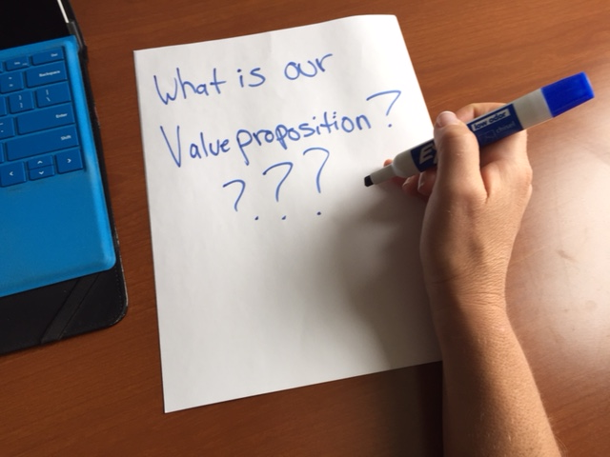
Need help articulating your value proposition in one succinct sentence that you can quickly communicate to customer in 30 seconds? We have created a free value proposition generator tool to help you. Click here to define your value proposition in the next 5 minutes!

Click here to receive a first draft of your value proposition at no cost to you!

(BUTTON) Free Value proposition worksheet

LINK TO http://neuralimpact.ca/valueproposition/

For more reading on this topic see Michael Treacy’s book "The Discipline of Market Leaders," https://www.amazon.com/Discipline-Market-Leaders-Customers-Dominate/dp/0201407191

